# Ex:4 Create UDF (User Defined Functions) in Apache Pig

# and execute it in MapReduce/HDFS mode

**AIM:**

To create UDF (User Defined Functions) in Apache Pig and execute it in MapReduce/HDFS mode.

# PROCEDURE:

1. Ensure that Apache Pig is installed and configured.
2. 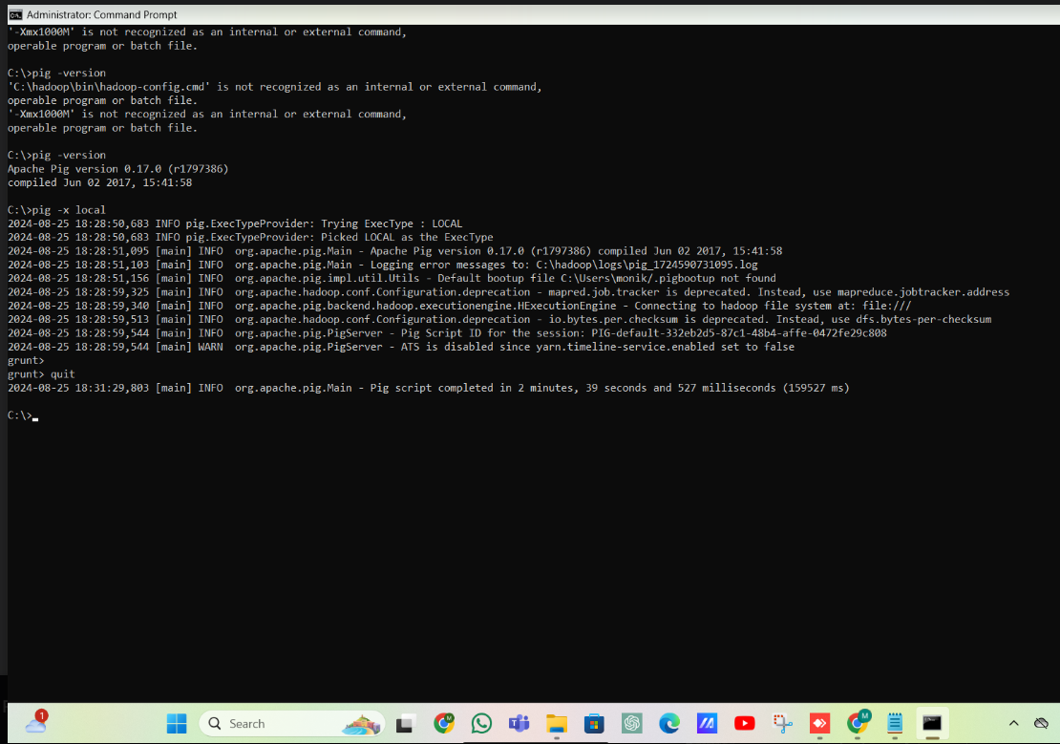
3. Create a python UDF (User Defined Functions).

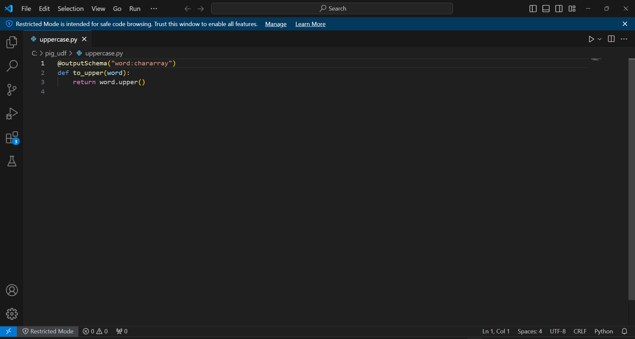

1. Jython should be installed as Pig will use it to interpret the Python UDFs.
2. Create a Pig script that registers and uses the Python UDF.

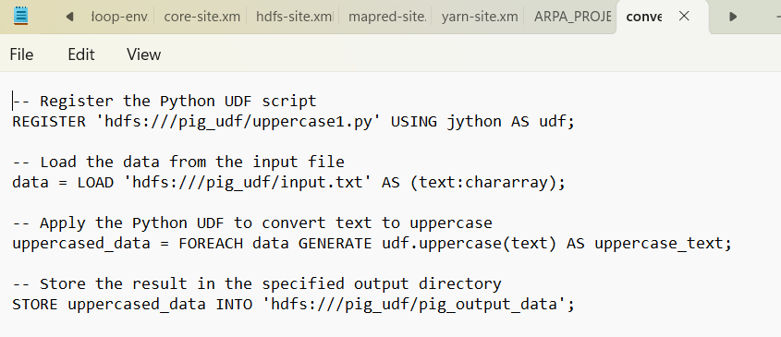

1. Execute the Pig Script in MapReduce Mode using the command: pig -x mapreduce script.pig

# OUTPUT:

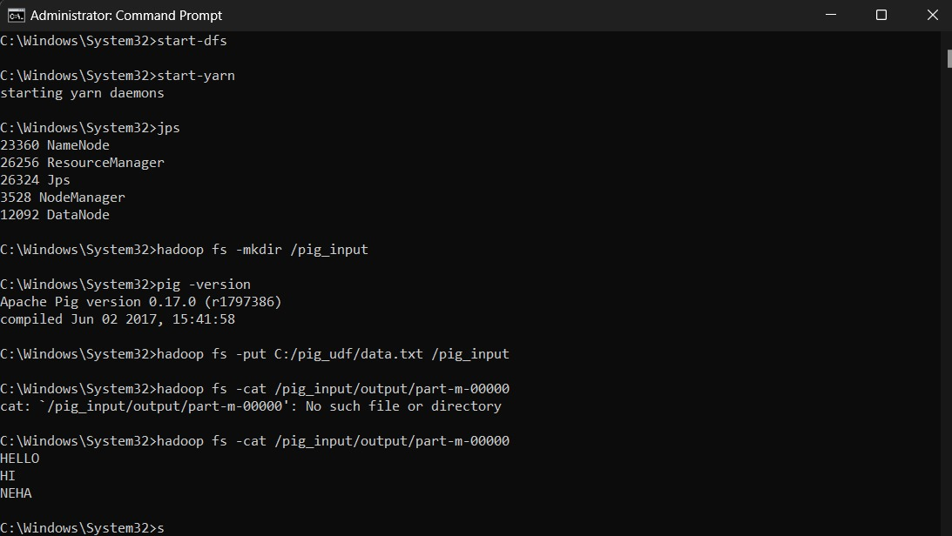

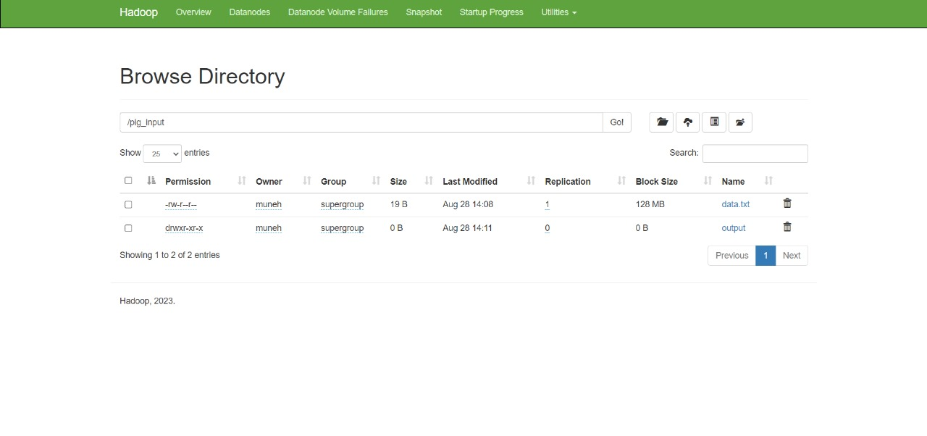

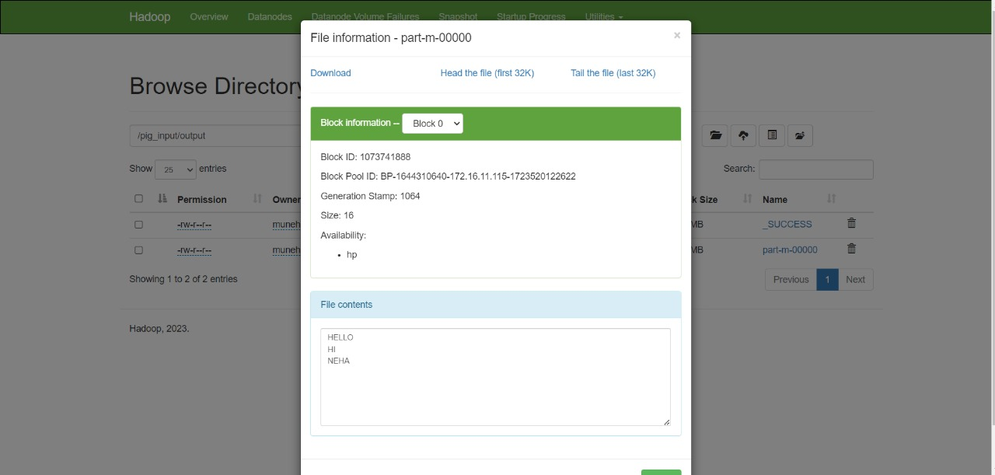

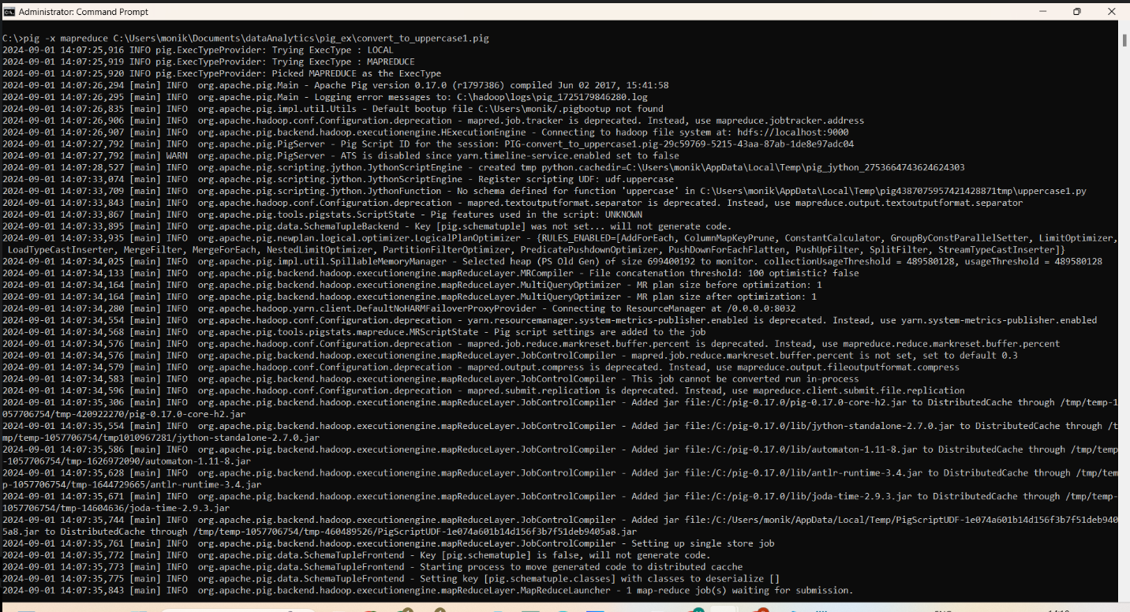

**RESULT:**

Thus, to create a UDF in Apache Pig and execute in MapReduce mdoe has been executed successful.